Rapture Warning
July 10th, 2021

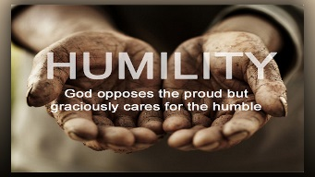
May the peace and joy of our Lord be with you all dear Heartdwellers. Mother Clare began, “Lord, is it true? Could the Rapture really happen now?”

Jesus replied, “Yes, it is true and it is best to warn your people. Tell them for Me that the world is in a most precarious position and very vulnerable to take over.”

But Lord I thought all the Cabal was taken down?

Jesus continued, “All I can tell you is that My Father has indicated that it may happen now. There is no solid word as yet, just a very concerning warning.”

“Oh, dear God, I am so tired. But I know You can change that in a heartbeat if you so desire. Yet, I have to say, the Rapture would be wonderful. I would love it, and I think I’m done with trying to do so much more with this worn out heart, mind and body.”

“You are not the only one Clare. This is the condition of My well-worn bride right now. Be on your guard. Watch, pray and be prepared, truly, it could happen at any moment.”

“But Lord.”

Jesus continued, “Things are very tense right now and what has been planned against you and the world is not pretty. There are plenty of thugs to still make a real mess. They can never round them all up. There are too many. Let’s just say there are many more than was anticipated and this is one reason for all the delays.”

“The next question is where will ‘we’ go when things truly begin to fall apart?”

The Lord replied, “People are not ready for what is coming. But I am and I will never let My chosen ones down. And those who are not ready, have not been paying attention and listening very carefully to My prophets. It’s coming down, but those who were not ready will be buried in a landslide.

“This is why I told the Satanists that they would be busy trying to survive and not have time for cursing parties.” And that was the end of His message.

Love and peace to you all dear Heartdwellers.

Let us prepare ourselves to stay focused on the Lord and on heavenly things above.

